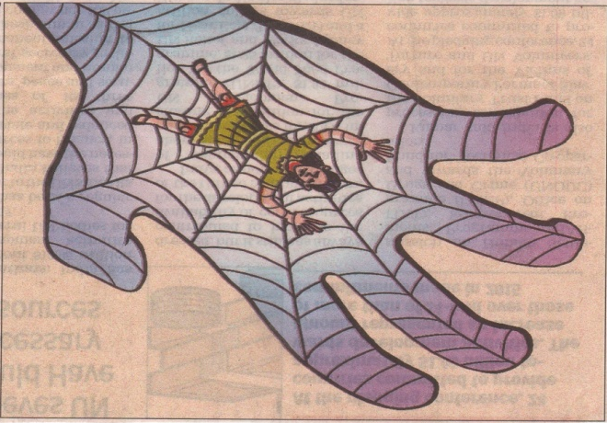
Protecting and providing education to the girl children - worthwhile human endeavour!
Recently we have adopted a five year old girl child through our care and protection programme. She is from one of the tribal hamlets of Western Ghats. The parents, who go for collecting non-timber forest produces (NTFP) for their livelihood, leave their children in a cradle under the tree. The child miraculously escaped from a herd of elephants which often strayed in to these hamlets and cause extensive damages to crops in farmlands and trampling to death of few villagers. Leave alone her growth and education, the very survival of the girl child is under threat in these circumstances.

When we received the child, we were concerned about her separation anxiety disorder as leaving her mother to stay in a new environment. But to our surprise, she is happy and very accommodative along with other children who grow up here. Usually girl children from these hamlets won’t be sent to schools for their education and the adolescent girls will be either at home doing domestic help or helping their parents while collecting NTFP. Some of them will be sent as bonded labourers to tea estates or to hosiery companies for many years.

The birth of girl children, their growth, education and safety are still challenging issues in countries like India, the largest democracy in the world. To mention a few:
- 444 Million Children below 18 years of Age which contribute 37% of total population.
- 25 million are abandoned
- Around 8.5 lakh children are estimated to die before their first birthday each year (Census 2011 and Sample Registration System (SRS) 2013)
- About 3 million girls are out of school in India and estimates show that for every 100 girls in rural India, only 1 reaches class 12
- 1 in every 3 child brides in the world is a girl in India (UNICEF)
- Every 8 minutes, a child goes missing in India and As per a census conducted in 2011, there are 82 lakh child labourers in India

These alarming numbers shows our social apathy towards children. All of us should take the responsibility including the Government, Politicians, Government Officials, Civil Society Organisations, Media and the Common Man for building our own children’s future together results a better life for all of us!
UNESCO succinctly pointed that Girls’ education has a huge impact on all of society as
- Educated women are less likely to die in childbirth
- Educating girls can save millions of lives
- Mothers’ education improves child nutrition
- Girls with higher levels of education are less likely to have children at an early age
- Girls with higher levels of education are less likely to get married at an early age
- Education narrows pay gaps between men and women

So it is evident that Girl’s education is not only for her, it is for her whole family and for the overall development of the nation. SJDT’s effort of reaching out to these children and bringing up them is certainly a worthwhile human endeavour. And we are very thankful to all those who support us in this journey.

Bro. I. Sebastian M.A., M.B.A., PH.D

Executive Director

St. Joseph’s Development Trust

Genguvarpatty

Periyakulam( T.K)

Theni(Dt)

